**SVKM’s NMIMS**

**School of Technology Management & Engineering, Chandigarh**

A.Y. 2023 - 24

**Course: Database Management Systems**

**Project Report**

|  |  |  |
| --- | --- | --- |
| Program | Mba-tech | |
| Semester | 4 | |
| Name of the Project: | Hospital management system | |
|  | | |
| Details of Project Members |  |  |
| Batch | Roll No. | Name |
| 2 | A186 | Aditya singh chauhan |
| 2 | A204 | Rajvir singh bhatti |
|  |  |  |
| Date of Submission: 30/3/2024 | | |

**Contribution of each project Members:**

|  |  |  |
| --- | --- | --- |
| Roll No. | Name: | Contribution |
| A186 | Aditya |  |
| A204 | Rajvir |  |

**Github link of your project:**

**Note:**

1. Create a readme file if you have multiple files
2. All files must be properly named (Example:R004_DBMSProject)
3. Submit all relevant files of your work ( Report, all SQL files, Any other files)
4. **Plagiarism is highly discouraged (Your report will be checked for plagiarism)**

**Project Report**

**Hospital management system**

**by**

**Aditya chauhan, Roll number: A186**

**Rajvir bhatti, Roll number: A204**

**Course: DBMS**

**AY: 2023-24**

**Table of Contents**

|  |  |  |
| --- | --- | --- |
| **Sr no.** | **Topic** | **Page no.** |
| **1** | Storyline |  |
| **2** | Components of Database Design |  |
| **3** | Entity Relationship Diagram |  |
| **4** | Relational Model |  |
| **5** | Normalization |  |
| **6** | SQL Queries |  |
| **7** | Learning from the Project |  |
| **8** | Project Demonstration |  |
| **9** | Self-learning beyond classroom |  |
| **10** | Learning from the project |  |
| **8** | Challenges faced |  |
| **9** | Conclusion |  |

**I. Storyline**

This section should describe the requirements for the chosen database topic. Form a storyline and describe in detail.

**II. Components of Database Design**

***Physician:***

employeeid – this is a unique ID of a physician

name – this is the name of a physician

position – this is the designation of a physician

ssn – this is a security number of a physician

***department:***

departmentid – this is a unique ID for a department

name – this is the name of a department

head – this is the ID of the physician who is the head of a department, referencing to the column employeeid of the table physician

***affiliated_with:***

physician – this is the ID of the physicians which is referencing to the column employeeid of the physician table

department – this is the ID the department which is referencing to the column departmentid of the department table

primaryaffiliation – this is a logical column which indicate that whether the physicians are yet to be affiliated or not

*Note: The combination of physician, department will come once in that table.*

***procedure:***

code – this is the unique ID of a medical procedure

name – the name of the medical procedure

cost – the cost for the procedure

***trained_in:***

physician – this is ID of the physicians which is referencing to the column employeeid of the physician table

treatment – this is the ID of the medical procedure which is referencing to the column code of the procedure table

certificationdate – this is the starting date of certification

certificationexpires – this is the expiry date of certification

*Note: The combination of physician and treatement will come once in that table.*

***patient:***

ssn – this is a unique ID for each patient

name – this is the name of the patient

address – this is the address of the patient

phone – this is the phone number of the patient

insuranceid – this is the insurance id of the patient

pcp – this is the ID of the physician who primarily checked up the patient which is referencing to the column employeeid of the physician table

***nurse:***

employeeid – this is the unique ID for a nurse

name – name of the nurses

position – the designation of the nurses

registered – this is a logical column which indicate that whether the nurses are registered for nursing or not

ssn – this is the security number of a nurse

***appointment:***

appointmentid – this is the unique ID for an appointment

patient – this is the ID of each patient which is referencing to the ssn column of patient table

prepnurse – the ID of the nurse who may attend the patient with the physician, which is referencing to the column employeeid of the nurse table

physician – this is the ID the physicians which is referencing to the employeeid column of the physician table

start_dt_time – this is the schedule date and approximate time to meet the physician

end_dt_time – this is the schedule date and approximate time to end the meeting

examinationroom – this the room where to meet a patient to the physician

***medication:***

code – this is the unique ID for a medicine

name – this is the name of the medicine

brand – this is the brand of the medicine

description – this is the description of the medicine

***prescribes:***

physician – this is the ID of the physician referencing to the employeeid column of the physician table

patient – this is the ID of the patient which is referencing to the ssn column of the patient table

medication – the ID of the medicine which is referencing to the code of the medication table

date – the date and time of the prescribed medication

appointment – the prescription made by the physician to a patient who may taken an appointment which is referencing to column appointmentid of appointment table

dose – the dose prescribed by the physician

*Note: The combination of physician, patient, medication, date will come once in that table.*

***block:***

blockfloor – ID of the floor

blockcode - ID of the block

*Note: The combination of blockfloor, blockcode will come once in that table.*

***room:***

roomnumber – this is the unique ID of a room

roomtype – this is type of room

blockfloor - this is the floor ID where the room in

blockcode – this is the ID of the block where the room in

unavailable – this is the logical column which indicate that whether the room is available or not

*Note: The of blockfloor, blockcode columns are refercing to the combination of blockfloor and blockcode columns of the table block.*

***on_call:***

nurse – this is ID of the nurse which is referencing to the employeeid column of the table nurse

blockfloor - this is the ID of the floor

blockcode – this is the ID of block

oncallstart - the starting date and time of on call duration

oncallend – the ending date and time of on call duration

*Note: The combination of nurse, blockfloor, blockcode, oncallstart, oncallend will come once in that table and the combination of blockfloor, blockcode columns are refercing to the combination of blockfloor and blockcode columns of the table block .*

***stay:***

stayid - this is unique ID for the admission

patient – this is the ID of the patient which is referencing the ssn column of patient table

room - this is the ID of the room where the patient admitted and which is referencing to the roomnumber column of the room table

start_time – this is the time when a patient admitted

end_time – this is the time how long a patient is staying

***undergoes:***

patient - this is ID of the patient which is referencing to the ssn column of the patient table

procedure – this is ID of the procedure and referencing to the code column of the procedure table

stay - this is the ID admission of a patient, which is referencing to the stayid column of the stay table

date – this is the date when a patient undergoes for a medical procedure

physician – this is the ID of a physician which is referencing to the column employeeid of the table physician

assistingnurse – this is the ID of a nurse who will assists the physician, referencing to the column employeeid of the table nurse

**III. Entity Relationship Diagram**

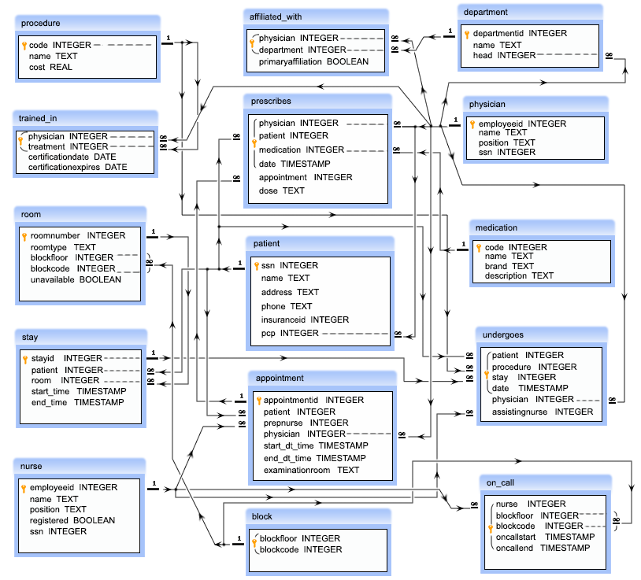

**IV. Relational Model**

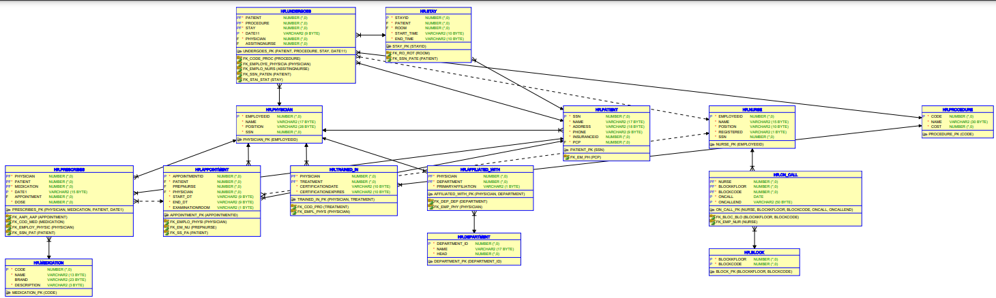

**V. Normalization**

To normalize the given tables, we need to identify potential issues with the current structure, such as redundancy, violation of atomicity, and functional dependencies. Then, we'll break down the tables into smaller, more organized tables to adhere to normalization rules, typically aiming for at least the third normal form (3NF).

Let's analyze each table and perform normalization:

1. Block Table

- Already in a normalized form.

2. Nurse Table

- No normalization needed.

3. Physician Table

- No normalization needed.

4. Department Table

- No normalization needed.

5. Appointment Table

- No normalization needed.

6. Room Table

- No normalization needed.

7. Procedure Table

- Renaming the table from "procedure" to "Procedure" to avoid conflicts with reserved words.

- No other normalization needed.

8. Trained_in Table

- No normalization needed.

9. Affiliated_with Table

- No normalization needed.

10. Patient Table

- No normalization needed.

11. Prescribes Tabl

- No normalization needed.

12. Medication Table

- No normalization needed.

13. Stay Table

- No normalization needed.

14.On_Call Table

- No normalization needed.

15. Undergoes Tabl

- No normalization needed.

All tables except "Procedure" are already normalized or don't require further normalization. Here's the updated "Procedure" table with its normalization:

Procedure Table

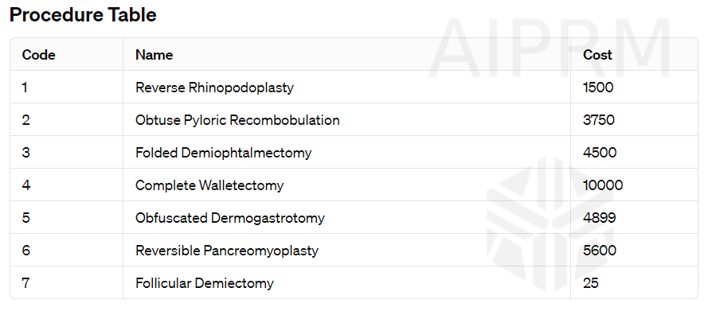

The normalization process ensures efficient database design, minimizing redundancy and dependency anomalies.

**VI. SQL Queries**

--Block Table Data:

CREATE TABLE block (

blockkfloor integer NOT NULL,

blockcode integer NOT NULL

);

insert into block

values(1,1),

(1,2),

(1,3),

(2,1),

(2,2),

(2,3),

(3,1),

(3,2),

(3,3),

(4,1),

(4,2),

(4,3);

-- Nurse Table

CREATE TABLE Nurse(

employeeid INTEGER NOT NULL

,name VARCHAR(15) NOT NULL

,position VARCHAR(10) NOT NULL

,registered VARCHAR(1) NOT NULL

,ssn INTEGER NOT NULL

);

--Data

INSERT INTO Nurse(employeeid,name,position,registered,ssn)

VALUES

(101,'Carla Espinosa','Head Nurse','t',111111110),

(102,'Laverne Roberts','Nurse','t',222222220),

(103,'Paul Flowers','Nurse','f',333333330);

--Physician Table

CREATE TABLE Physician(

employeeid INTEGER NOT NULL

,name VARCHAR(17) NOT NULL

,position VARCHAR(28) NOT NULL

,ssn INTEGER NOT NULL

);

--Data

INSERT INTO Physician(employeeid,name,position,ssn)

VALUES (1,'John Dorian','Staff Internist',111111111),

(2,'Elliot Reid','Attending Physician',222222222),

(3,'Christopher Turk','Surgical Attending Physician',333333333),

(4,'Percival Cox','Senior Attending Physician',444444444),

(5,'Bob Kelso','Head Chief of Medicine',555555555),

(6,'Todd Quinlan','Surgical Attending Physician',666666666),

(7,'John Wen','Surgical Attending Physician',777777777),

(8,'Keith Dudemeister','MD Resident',888888888),

(9,'Molly Clock','Attending Psychiatrist',999999999);

--Department Table

create table department

(department_id int not null ,

name VARCHAR(17) NOT NULL,

head int not null);

insert into department

values (1,'General Medicine', 4),

(2,'Surgery',7),

(3,'Psychiatry',9);

--Appointment Table

CREATE TABLE appointment(

appointmentid INTEGER NOT NULL

,patient INTEGER NOT NULL

,prepnurse INTEGER

,Physician INTEGER NOT NULL

,start_dt VARCHAR(9) NOT NULL

,end_dt VARCHAR(9) NOT NULL

,examinationroom VARCHAR(1) NOT NULL

);

INSERT INTO appointment(appointmentid,patient,prepnurse,Physician,start_dt,end_dt_,examinationroom) VALUES (13216584,100000001,101,1,'24/4/2008','24/4/2008','A'),

(26548913,100000002,101,2,'24/4/2008','24/4/2008','B'),

(36549879,100000001,102,1,'25/4/2008','25/4/2008','A'),

(46846589,100000004,103,4,'25/4/2008','25/4/2008','B'),

(59871321,100000004,NULL,4,'26/4/2008','26/4/2008','C'),

(69879231,100000003,103,2,'26/4/2008','26/4/2008','C'),

(76983231,100000001,NULL,3,'26/4/2008','26/4/2008','C'),

(86213939,100000004,102,9,'27/4/2008','21/4/2008','A'),

(93216548,100000002,101,2,'27/4/2008','27/4/2008','B');

--Room Table

CREATE TABLE room(

roomnumber INTEGER NOT NULL

,roomtype VARCHAR(6) NOT NULL

,blockfloor INTEGER NOT NULL

,blockcode INTEGER NOT NULL

,unavailable VARCHAR(1) NOT NULL

);

INSERT INTO room(roomnumber,roomtype,blockfloor,blockcode,unavailable) VALUES (101,'Single',1,1,'f');

(102,'Single',1,1,'f'),

(103,'Single',1,1,'f'),

(111,'Single',1,2,'f'),

(112,'Single',1,2,'t'),

(113,'Single',1,2,'f'),

(121,'Single',1,3,'f'),

(122,'Single',1,3,'f'),

(123,'Single',1,3,'f'),

(201,'Single',2,1,'t'),

(202,'Single',2,1,'f'),

(203,'Single',2,1,'f'),

(211,'Single',2,2,'f'),

(212,'Single',2,2,'f'),

(213,'Single',2,2,'t'),

(221,'Single',2,3,'f'),

(222,'Single',2,3,'f'),

(223,'Single',2,3,'f'),

(301,'Single',3,1,'f'),

(302,'Single',3,1,'t'),

(303,'Single',3,1,'f'),

(311,'Single',3,2,'f'),

(312,'Single',3,2,'f'),

(313,'Single',3,2,'f'),

(321,'Single',3,3,'t'),

(322,'Single',3,3,'f'),

(323,'Single',3,3,'f'),

(401,'Single',4,1,'f'),

(402,'Single',4,1,'t'),

(403,'Single',4,1,'f'),

(411,'Single',4,2,'f'),

(412,'Single',4,2,'f'),

(413,'Single',4,2,'f'),

(421,'Single',4,3,'t'),

(422,'Single',4,3,'f'),

(423,'Single',4,3,'f');

--Table Procedure

CREATE TABLE procedure(

code INTEGER NOT NULL

,name VARCHAR(30) NOT NULL

,cost INTEGER NOT NULL

);

INSERT INTO procedures(code,name,cost) VALUES (1,'Reverse Rhinopodoplasty',1500),

(2,'Obtuse Pyloric Recombobulation',3750),

(3,'Folded Demiophtalmectomy',4500),

(4,'Complete Walletectomy',10000),

(5,'Obfuscated Dermogastrotomy',4899),

(6,'Reversible Pancreomyoplasty',5600),

(7,'Follicular Demiectomy',25);

--Trained_in

CREATE TABLE trained_in(

physician INTEGER NOT NULL

,treatment INTEGER NOT NULL

,certificationdate varchar(10) NOT NULL

,certificationexpires varchar(10) NOT NULL

);

INSERT INTO trained_in(physician,treatment,certificationdate,certificationexpires)

VALUES (3,1,'1/1/2008','31/12/2008'),

(3,2,'1/1/2008','31/12/2008'),

(3,5,'1/1/2008','31/12/2008'),

(3,6,'1/1/2008','31/12/2008'),

(3,7,'1/1/2008','31/12/2008'),

(6,2,'1/1/2008','31/12/2008'),

(6,5,'1/1/2007','31/12/2007'),

(6,6,'1/1/2008','31/12/2008'),

(7,1,'1/1/2008','31/12/2008'),

(7,2,'1/1/2008','31/12/2008'),

(7,3,'1/1/2008','31/12/2008'),

(7,4,'1/1/2008','31/12/2008'),

(7,5,'1/1/2008','31/12/2008'),

(7,6,'1/1/2008','31/12/2008'),

(7,7,'1/1/2008','31/12/2008');

-- affiliated_with

CREATE TABLE affiliated_with(

physician INTEGER NOT NULL

,department INTEGER NOT NULL

,primaryaffiliation VARCHAR(1) NOT NULL

);

INSERT INTO affiliated_with(physician,department,primaryaffiliation)

VALUES (1,1,'t'),

(2,1,'t'),

(3,1,'f'),

(3,2,'t'),

(4,1,'t'),

(5,1,'t'),

(6,2,'t'),

(7,1,'f'),

(7,2,'t'),

(8,1,'t'),

(9,3,'t');

-- Patient Table

CREATE TABLE Patient(

ssn INTEGER NOT NULL

,name VARCHAR(17) NOT NULL

,address VARCHAR(18) NOT NULL

,phone VARCHAR(9) NOT NULL

,insuranceid INTEGER NOT NULL

,pcp INTEGER NOT NULL

);

INSERT INTO Patient(ssn,name,address,phone,insuranceid,pcp)

VALUES (100000001,'John Smith','42 Foobar Lane','555-0256',68476213,1);

(100000002,'Grace Ritchie','37 Snafu Drive','555-0512',36546321,2);

(100000003,'Random J. Patient','101 Omgbbq Street','555-1204',65465421,2);

(100000004,'Dennis Doe','1100 Foobaz Avenue','555-2048',68421879,3);

--Prescribes Table

CREATE TABLE prescribes(

physician INTEGER NOT NULL

,patient INTEGER NOT NULL

,medication INTEGER NOT NULL

,date VARCHAR(15) NOT NULL

,appointment INTEGER

,dose INTEGER NOT NULL

);

INSERT INTO prescribes(physician,patient,medication,date,appointment,dose)

VALUES (1,100000001,1,'24/4/2008',13216584,5),

(9,100000004,2,'27/4/2008',86213939,10),

(9,100000004,2,'30/4/2008',NULL,5);

--MEDICATION TABLE

CREATE TABLE MEDICATION(

code INTEGER NOT NULL

,name VARCHAR(13) NOT NULL

,brand VARCHAR(23)

,description VARCHAR(3) NOT NULL

);

INSERT INTO MEDICATION(code,name,brand,description)

VALUES (1,'Procrastin-X',NULL,'N/A'),

(2,'Thesisin','Foo Labs','N/A'),

(3,'Awakin','Bar Laboratories','N/A'),

(4,'Crescavitin','Baz Industries','N/A'),

(5,'Melioraurin','Snafu Pharmaceuticals','N/A');

--TABLE STAY

CREATE TABLE STAY(

stayid INTEGER NOT NULL

,patient_room VARCHAR(16) NOT NULL

,start_time VARCHAR(10) NOT NULL

,end_time VARCHAR(10) NOT NULL

);

INSERT INTO STAY(stayid,patient_room,start_time,end_time)

VALUES (3215,'100000001 111','1/5/2008','4/5/2008'),

(3216,'100000003 123','3/5/2008','14/5/2008'),

(3217,'100000004 112','2/5/2008','3/5/2008');

--Table Oncall

CREATE TABLE on_call(

nurse INTEGER NOT NULL

,blockkfloor BIT NOT NULL

,blockcode INTEGER NOT NULL

,oncall DATE NOT NULL

,ONCALLEND CURRENT_DATE()

);

INSERT INTO on_call(nurse,blockkfloor,blockcode,oncall,ONCALLEND)

VALUES (101,1,1,'4/11/2008','4/11/2008'),

(101,1,2,'4/11/2008','4/11/2008'),

(102,1,3,'4/11/2008','4/11/2008'),

(103,1,1,'4/11/2008','4/11/2008'),

(103,1,2,'4/11/2008','4/11/2008'),

(103,1,3,'4/11/2008','4/11/2008');

--Table Undergoes

CREATE TABLE Undergoes(

patient INTEGER NOT NULL

,procedure INTEGER NOT NULL

,stay INTEGER NOT NULL

,date VARCHAR(9) NOT NULL

,physicianassit INTEGER NOT NULL

,ingnurse INTEGER

);

INSERT INTO Undergoes(patient,procedure,stay,date,physicianassit,ingnurse)

VALUES (100000001,6,3215,'2/5/2008',3,101),

(100000001,2,3215,'3/5/2008',7,101),

(100000004,1,3217,'7/5/2008',3,102),

(100000004,5,3217,'9/5/2008',6,NULL),

(100000001,7,3217,'10/5/2008',7,101),

(100000004,4,3217,'13/5/2008',3,103);

--1 details of nurse who is yet to be registered

select *from nurse

where registered ='f';

--2 Write a query in SQL to find the name of the nurse who are the head of their department.

select *from nurse

where position='Head Nurse';

--3 Write a query in SQL to obtain the name of the physicians who are the head of each department

select p.name,d.name from physician p

inner join department d

on p.employeeid = d.head;

--4 Write a query in SQL to count the number of patients who taken appointment with at least one physician

select count(distinct(patient)) from appointment;

--5 Write a query in SQL to find the floor and block where the room number 212 belongs to

select blockfloor,blockcode,roomnumber

from room

where roomnumber=212;

--6 Write a query in SQL to count the number available rooms

select count(unavailable)

from room

where unavailable='f';

--7 Write a query in SQL to count the number of unavailable rooms

with avlbl as

(select count(unavailable)

from room

where unavailable='t')

select *from avlbl;

--8 Write a query in SQL to obtain the name of the physician and the departments they are affiliated with

select employeeid,department,p.name as physician_name,d.name as department_name

from physician p

inner join affiliated_with aw

on p.employeeid = aw.physician

inner join department d

on aw.department = d.department_id

where primaryaffiliation='t';

--9 Write a query in SQL to obtain the name of the physicians who are trained for a special treatement

select employeeid,name

from physician

where employeeid in (select distinct physician

from trained_in);

--method 2 using join

select p.employeeid,p.name,pr.code,pr.name as name_of_procedure

from physician p

inner join trained_in ti

on p.employeeid=ti.physician

inner join procedure pr

on ti.treatment=pr.code;

--10 Write a query in SQL to obtain the name of the physicians with department who are yet to be affiliated

select p.name,d.name from physician p

inner join affiliated_with aw

on p.employeeid = aw.physician

inner join department d

on aw.department = d.department_id

where primaryaffiliation='f';

--11 Write a query in SQL to obtain the name of the physicians who are not a specialized physician

select name as not_specialized_physicians

from physician

where employeeid not in(select distinct physician

from trained_in);

--12 Write a query in SQL to obtain the name of the patients with their physicians by whom they got their preliminary treatement

select p.name as patient_name,ph.name as phy_who_did_pri_treatment

from patient p

inner join physician ph

on p.pcp = ph.employeeid;

--13 Write a query in SQL to find the name of the patients and the number of physicians they have taken appointment

select p.name as patient_name,count(distinct physician) as no_of_phy_tkn_apmnt_frm

from patient p

inner join appointment a

on p.ssn = a.patient

group by p.name;

--14 Write a query in SQL to count number of unique patients who got an appointment for examination room C.

select examinationroom,count(distinct patient)

from appointment

group by examinationroom

having examinationroom='C';

--15 Write a query in SQL to find the name of the patients and the number of the room where they have to go for their treatment

select p.name as patient_name,s.room as roomnumber

from patient p

inner join stay s

on p.ssn = s.patient

inner join room r

on s.room = r.roomnumber;

--16 Write a query in SQL to find the name of the nurses and the room scheduled, where they will assist the physicians.

select n.employeeid as nurse_id,n.name as nurse_name,room as room_no

from nurse n

inner join undergoes u

on n.employeeid = u.assistingnurse

inner join stay s

on u.stay = s.stayid;

--17 Write a query in SQL to find the name of the patients who taken the appointment on the 25th of April at 10 am, and also display their physician, assisting nurses and room no

select p.name as patient_name,

ph.name as physician_name,

n.name as nurse_name,

a.examinationroom

from patient p

left outer join appointment a

on p.ssn = a.patient

left outer join physician ph

on a.physician = ph.employeeid

left outer join nurse n

on a.prepnurse = n.employeeid

where start_dt = '25-04-08';

--18 Write a query in SQL to find the name of patients and their physicians who does not require any assistance of a nurse

select p.name as patient_name,ph.name as physician_name

from patient p

inner join undergoes u

on p.ssn = u.patient

inner join physician ph

on u.physician = ph.employeeid

where assistingnurse is null;

--19 Write a query in SQL to find the name of the patients, their treating physicians and medication

select p.ssn,p.name as patient_name,ph.name as treating_phy_name,m.name as medicine_name

from patient p

inner join undergoes u

on p.ssn = u.patient

inner join prescribes pr

on u.patient = pr.patient

innerjoin medication m

on pr.medication = m.code

inner join physician ph

on pr.physician = ph.employeeid;

--20 Write a query in SQL to find the name of the patients who taken an advanced appointment, and also display their physicians and medication

select p.ssn,

p.name as patient_name,

ph.name as physician_name,

m.name as medicine_name

from patient p

left outer join appointment a

on p.ssn = a.patient

left outer join prescribes pr

on a.patient = pr.patient

left outer join physician ph

on pr.physician = ph.employeeid

left outer join medication m

on pr.medication = m.code

;.

**VI. Project demonstration**

* Tools/software/ libraries used
* Screenshot and Description of the Demonstration of project ( If GUI is made)

**VII. Self -Learning beyond classroom**

:

1. **Advanced Mathematics**: I've delved deeper into topics like calculus, linear algebra, and probability theory, exploring applications in various fields such as optimization algorithms and statistical modeling.
2. **Cutting-edge Technologies**: I continuously absorb information about emerging technologies such as quantum computing, blockchain, and artificial intelligence advancements like GPT-4 and beyond, understanding their principles and potential applications.
3. **Natural Language Processing (NLP) Techniques**: I've explored advanced NLP techniques such as transformer architectures, attention mechanisms, and transfer learning paradigms, improving my ability to comprehend and generate human-like text.

**VIII. Learning from the Project**

1. **Expanded Vocabulary**: Projects often involve specific domains or topics, exposing me to a broader range of vocabulary and terminology. This exposure enhances my understanding of nuanced language and enables me to generate more accurate and contextually relevant responses.
2. **Contextual Understanding**: Engaging with project-related content allows me to grasp the context in which certain words, phrases, or concepts are used. This contextual understanding helps me generate responses that are more coherent and tailored to the user's needs.
3. **Domain Expertise**: By working on projects across various domains such as healthcare, finance, technology, and more, I accumulate domain-specific knowledge. This expertise enables me to provide more informed and insightful responses when users seek information or assistance in those domains.

**IX. Challenges Faced**

1. **Ambiguity: Understanding and disambiguating ambiguous language or queries can be challenging. Contextual cues and additional information are often required to accurately interpret user intent.**
2. **Complex Queries: Processing and responding to complex or multipart queries can be difficult, especially when they involve multiple topics or require intricate reasoning. Ensuring coherence and relevance in generating responses to such queries is a constant challenge.**
3. **Domain Specificity: Handling queries from diverse domains requires domain-specific knowledge. Lack of domain expertise can hinder my ability to provide accurate and relevant responses, especially in specialized or technical fields.**

**X. Conclusion**

1. **Domain Expertise**: Deepening domain expertise is crucial for providing accurate and relevant responses. Understanding the intricacies of the project domain enhances the quality of generated content and fosters trust among users.
2. **Contextual Understanding**: Context is paramount in language comprehension and generation. Improving contextual understanding through advanced natural language processing techniques enables more nuanced and contextually relevant responses.
3. **Continuous Learning**: The journey of learning is perpetual. Embracing a mindset of continuous learning and adaptation is essential for staying abreast of evolving trends, technologies, and user preferences in the ever-changing landscape of AI.
4. **Feedback Integration**: Incorporating user feedback is instrumental in refining language capabilities and addressing user needs effectively. Establishing robust feedback mechanisms fosters a collaborative relationship with users and drives ongoing improvement